1.Create a **Log Analytics Workspace.**

First vm

Second vm

3.Enabling the monitoring insights for the two vms.

Review the map, which displays dependencies like processes running, ports open, connection details, health of the virtual machine, machine properties, and Azure virtual machine properties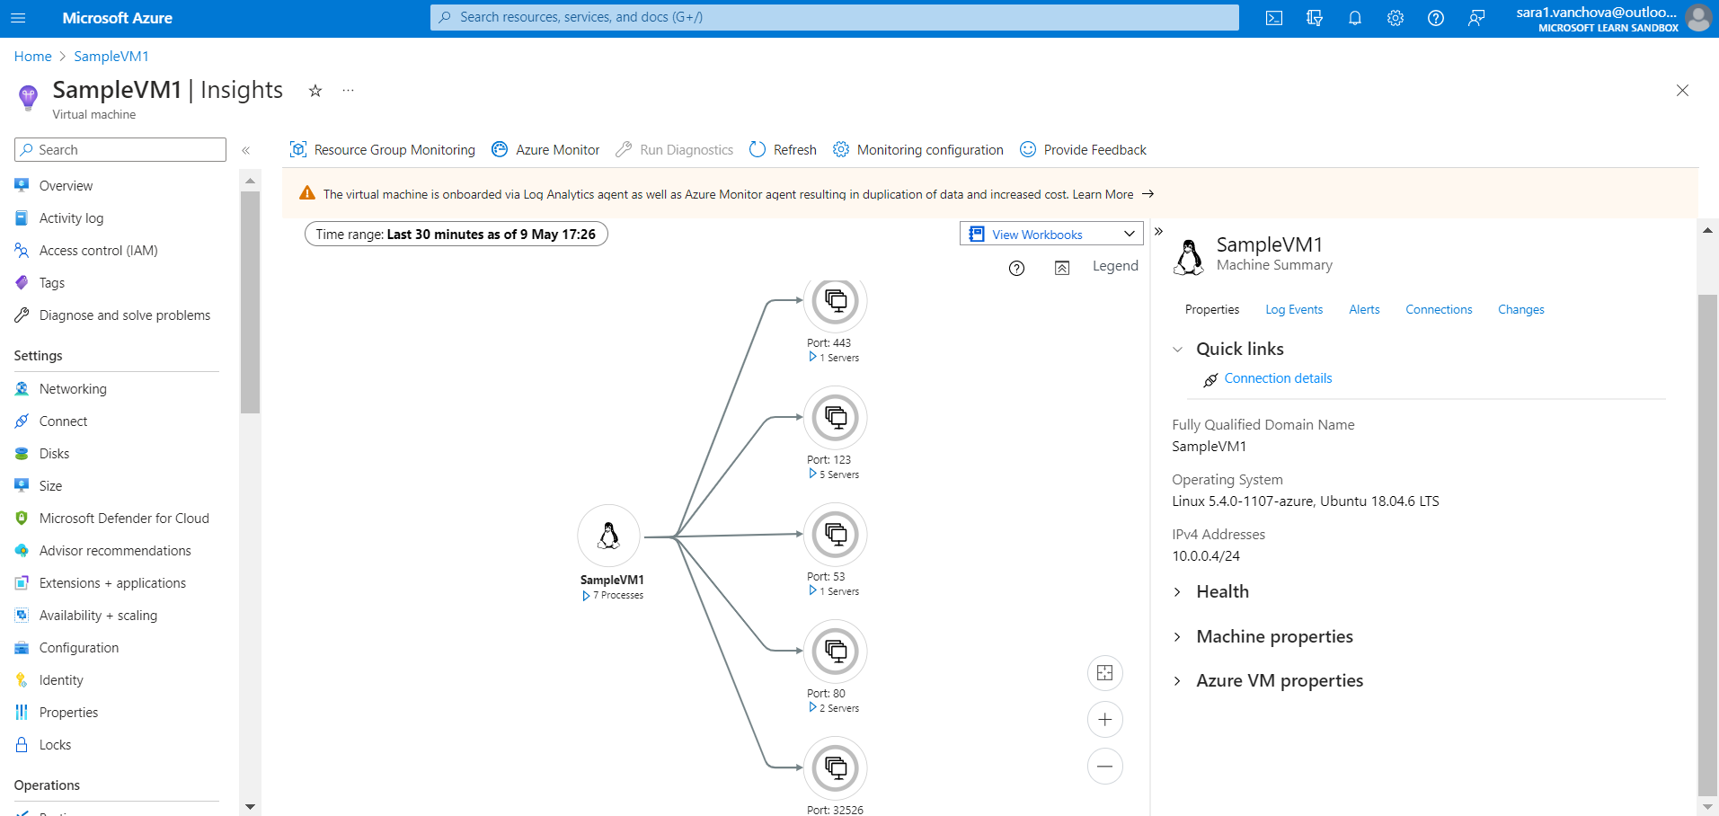

Properties

Log events insights

4. Queries

*Chart CPU usage trends by computer*

AVG

MAX